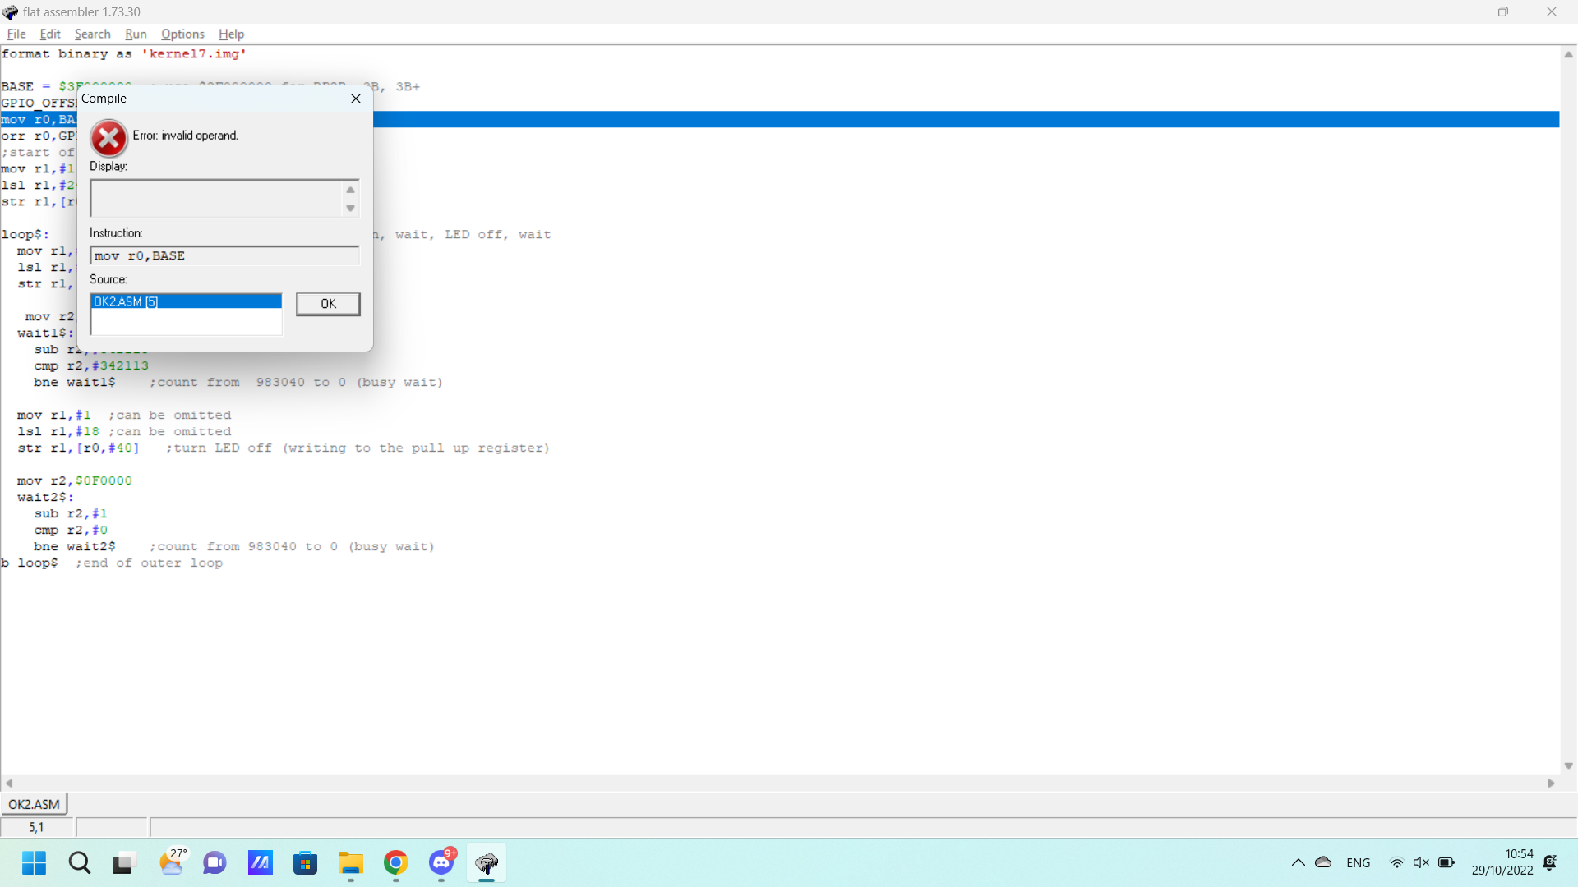

0x53861

It is defined by the instruction set

Using orr

mov r2, $0

orr r2, $340000

orr r2, $002100

orr r2, $000013

base = $3F000000

GPIO_OFFSET = $200000

mov r0,BASE

orr r0,GPIO_OFFSET

;start of GPIO

mov r1,#1

lsl r1,#24

str r1,[r0,#4]

output

loop$:

mov r1,#1

lsl r1,#18

str r1,[r0,#28]

mov r2,$0

orr r2, $342113

wait1$:

sub r2,#1

cmp r2,#0

bne wait1$

mov r1,#1

lsl r1,#18

str r1,[r0,#40]

mov r2,$0

orr r2, $342113

wait2$:

sub r2,#1

cmp r2,#0

bne wait2$

b loop$